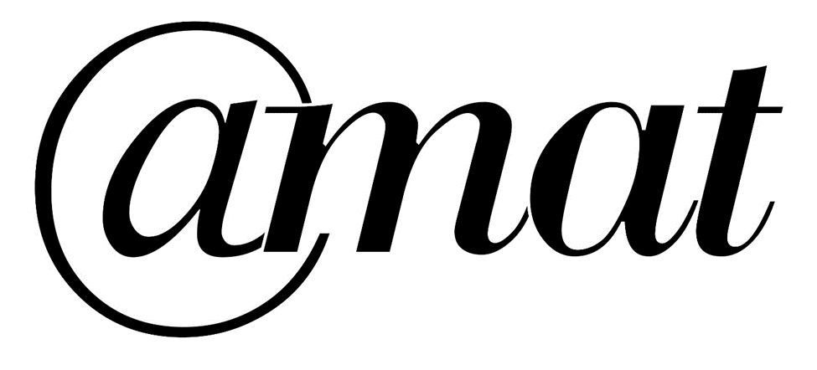

Gender Pay Gap Report 2023

The Cornovii Trust as an employer is required by law to carry out Gender Pay Reporting under the Equality Act 2010 (Gender Pay Gap Information) Regulations 2017. This involves carrying out six calculations that show the difference between the average earnings of men and women in our organisation. We are required to publish the results on our own website and a government website. We will do this within one calendar year of 31 March 2022.

We can use these results to assess:

• The levels of gender equality in our workplace
• The balance of male and female employees at different levels
• How effectively talent is being maximised and rewarded.

The results for the statutory calculations are:

The Mean Gender Pay Gap
The difference between the mean hourly rate of pay that male and female full-pay relevant employees receive: 13.33%.

This shows that, overall, female employees receive lower pay than male employees.

The Median Gender Pay Gap
The difference between the median hourly rate of pay that male and female full-pay relevant employees receive: 31.54%. Women earn 68p (68.46) for every £1 a male employee receives.

This shows that, typically, female employees receive lower pay than male employees.

The Mean Bonus Gender Pay Gap
The difference between the mean bonus pay that male and female relevant employees receive: 0%.

No members of staff have received a bonus in the period under review.

The Median Bonus Gender Pay Gap
The difference between the median bonus pay that male and female relevant employees receive: 0%.

The proportion of males and females receiving a bonus payment:

Proportion of male staff receiving a bonus: 0%
Proportion of female staff receiving a bonus: 0%

The proportion of males and females in each quartile pay band:

• Lower Pay Band Quartile Male Employees: 14.3% Female Employees: 85.7%

• Lower Middle Pay Band Quartile Male Employees: 20.0% Female Employees: 80.0%

• Upper Middle Pay Band Quartile Male Employees: 28.6% Female Employees: 71.4%

• Upper Pay Band Quartile Male Employees: 18.8% Female Employees: 81.2%

Supporting Statement and Narrative

The Cornovii Trust operates as an equal opportunities employer, and does not discriminate in any way (as defined by the Equalities Act 2010 and other relevant legislation), regarding recruitment, performance management and employee career development opportunities.

All employees are given equal treatment, regardless of gender. Men and women are paid equally for doing equivalent jobs across the Trust.

We have a Trust Pay Policy and the scale is reviewed in line with the national pay recommendations set out in the School Teachers Pay & Conditions Document and for our support staff we follow the NJC scale to ensure that our staff pay awards are competitive. The pay in these structures is exactly the same for a man or woman applying for a role.

It is clear from our data that 58% (33) of the 57 males are on higher salaries (leadership and teaching) and are predominantly full time as they fall within the upper and upper middle quartiles despite there being a higher percent of women (76%) within these quartiles. Within this 48% (106) of the 222 women are in the top two quartiles.

Therefore, we employ more women (52%) in the lower paid roles and substantially fewer men (42%) are in the lower paid roles (teaching assistants, middays & cleaners, many of which are part time). These part time roles are often held by primary carers seeking to balance employment opportunities and caring responsibilities and it is still the case, primary carers are more likely to be women.
No bonuses are paid to any Trust staff.

The Cornovii Trust is committed to developing talent within the trust which is evidenced by the number of female staff who join the trust in an entry level role and go on to be promoted to more senior higher earning roles.

The board of trustees reviewed this data and will consider the progress made on reducing the gender pay gap regularly.

Richard Middlebrook
Chief Executive Officer

